SIMATSENGINEERING

UNIT-3

LAB EXPERIMENTS

COURSE CODE: CSA1610 COURSE NAME: DWDM
D Bhavitha(192511152)

Q1:program

@relation transactions

@attribute a {yes,no}
@attribute b {yes,no}
@attribute c {yes,no}
@attribute d {yes,no}
@attribute e {yes,no}

@data
yes,no,yes,yes,no
yes,yes,yes,no,yes
yes,yes,no,yes,yes
yes,no,yes,yes,yes
no,yes,yes,no,yes
no,yes,no,yes,yes
no,no,yes,yes,no
yes,yes,yes,no,no
yes,no,no,yes,yes
yes,yes,no,no,yes

OUTPUT:

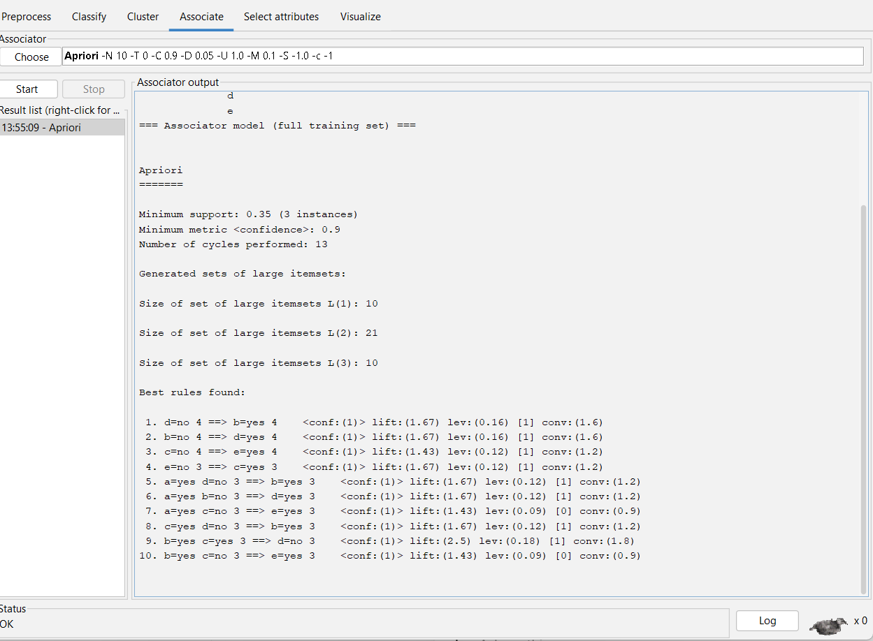

Q2:program

@relation marketbasket

@attribute Milk {yes,no}

@attribute Beer {yes,no}

@attribute Diapers {yes,no}

@attribute Bread {yes,no}

@attribute Butter {yes,no}

@attribute Cookies {yes,no}

@data

yes,yes,yes,no,no,no

yes,no,no,yes,yes,no

yes,no,yes,no,no,yes

no,no,no,yes,yes,yes

no,yes,yes,no,no,yes

yes,no,yes,yes,yes,no

no,no,yes,yes,yes,no

no,yes,yes,no,no,no

yes,no,yes,yes,yes,no

no,yes,no,no,no,yes

OUTPUT:

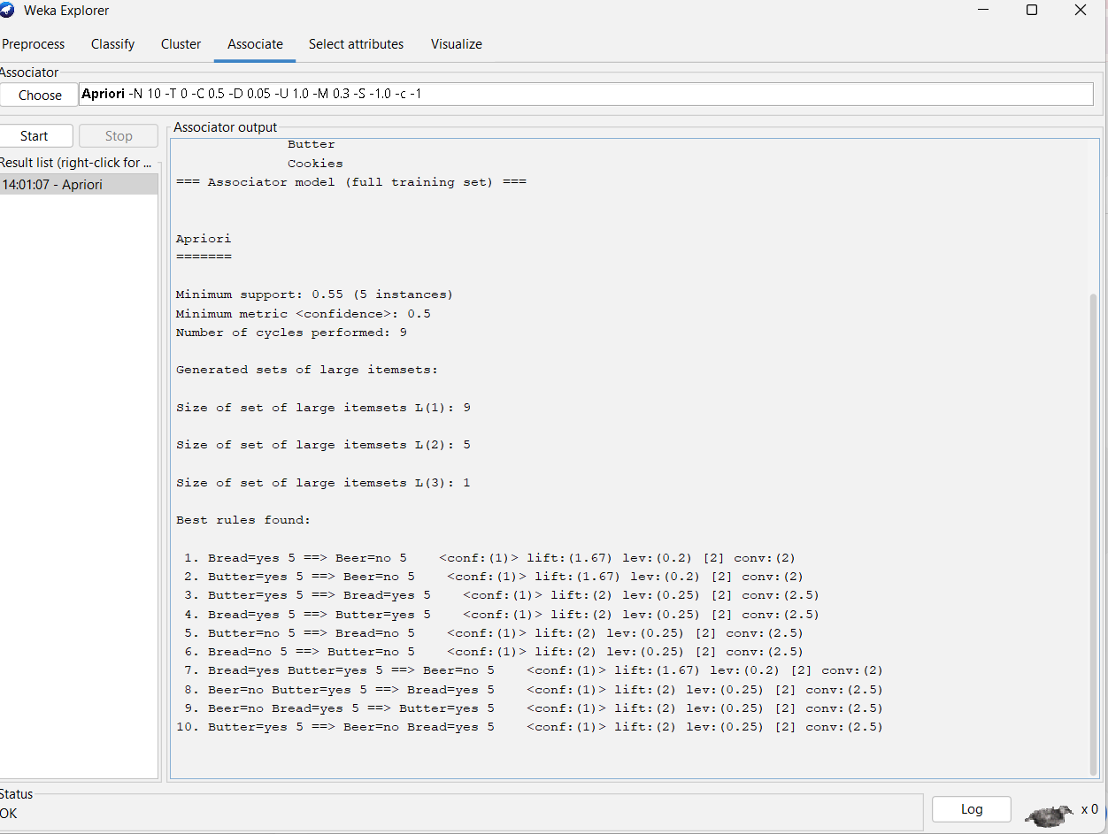

Q2:program
@relation computer_training

@attribute age {<=30,31..40,>40}
@attribute income {high,medium,low}
@attribute student {yes,no}
@attribute credit_rating {fair,excellent}
@attribute buys_computer {yes,no}

@data
<=30,high,no,fair,no
<=30,high,no,excellent,no
31..40,high,no,fair,yes
>40,medium,no,fair,yes
>40,low,yes,fair,yes
>40,low,yes,excellent,no
31..40,low,yes,excellent,yes
<=30,medium,no,fair,no
<=30,low,yes,fair,yes
>40,medium,yes,fair,yes
Output:
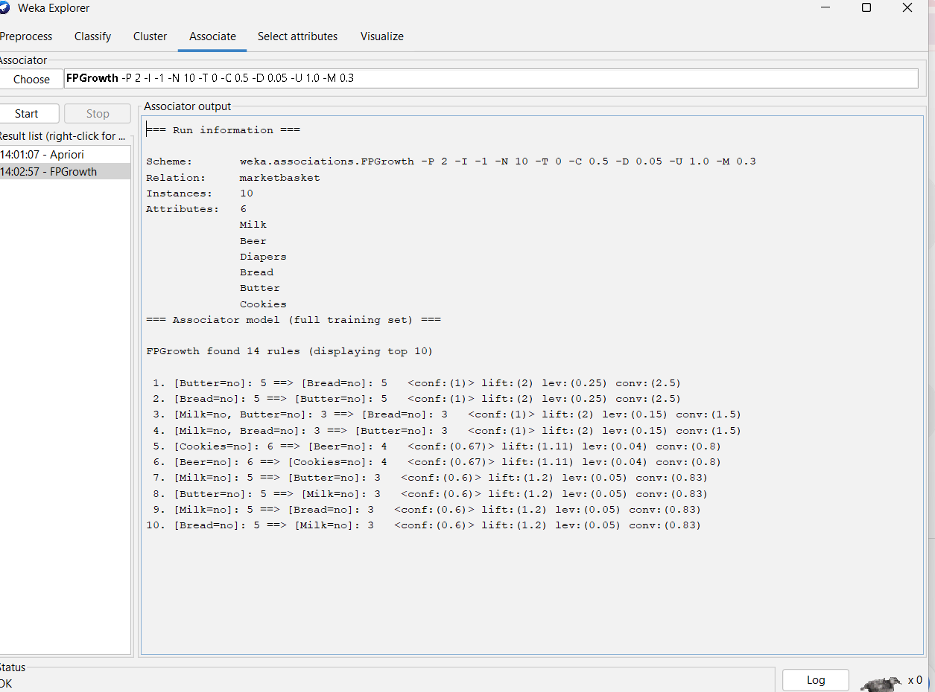
Q3:program
@relation diabetes
@attribute Pregnancies numeric
@attribute Glucose numeric
@attribute BloodPressure numeric
@attribute SkinThickness numeric
@attribute Insulin numeric
@attribute BMI numeric
@attribute DiabetesPedigreeFunction numeric
@attribute Age numeric
@attribute Outcome numeric

@data
6,148,72,35,0,33.6,0.627,50,1
1,85,66,29,0,26.6,0.351,31,0
8,183,64,0,0,23.3,0.672,32,1
1,89,66,23,94,28.1,0.167,21,0
0,137,40,35,168,43.1,2.288,33,1
5,116,74,0,0,25.6,0.201,30,0
3,78,50,32,88,31,0.248,26,1
10,115,0,0,0,35.3,0.134,29,0
2,197,70,45,543,30.5,0.158,53,1
8,125,96,0,0,0,0.232,54,1
4,110,92,0,0,37.6,0.191,30,0
10,168,74,0,0,38,0.537,34,1
10,139,80,0,0,27.1,1.441,57,0
1,189,60,23,846,30.1,0.398,59,1
5,166,72,19,175,25.8,0.587,51,1
7,100,0,0,0,30,0.484,32,1
0,118,84,47,230,45.8,0.551,31,1
7,107,74,0,0,29.6,0.254,31,1
1,103,30,38,83,43.3,0.183,33,0
1,115,70,30,96,34.6,0.529,32,1
Output:

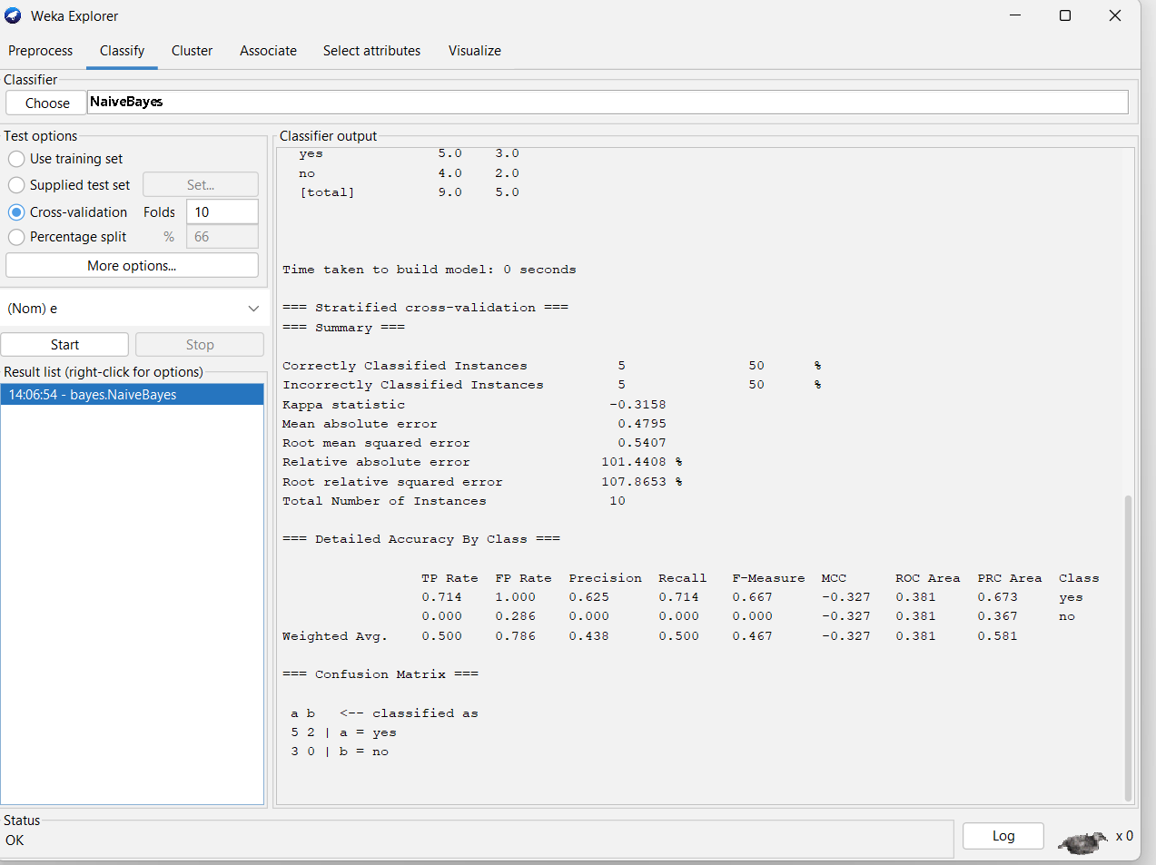
Q4:program
@relation transactions
@attribute M {yes,no}
@attribute O {yes,no}
@attribute N {yes,no}
@attribute K {yes,no}
@attribute E {yes,no}
@attribute Y {yes,no}
@attribute D {yes,no}
@attribute A {yes,no}
@attribute U {yes,no}
@attribute C {yes,no}
@attribute I {yes,no}

@data
yes,yes,yes,yes,yes,yes,no,no,no,no,no
no,yes,yes,yes,yes,yes,yes,no,no,no,no
yes,no,no,yes,yes,no,no,yes,no,no,no
yes,no,no,yes,no,yes,no,no,yes,yes,no
no,yes,no,yes,yes,no,no,no,no,yes,yes
output:
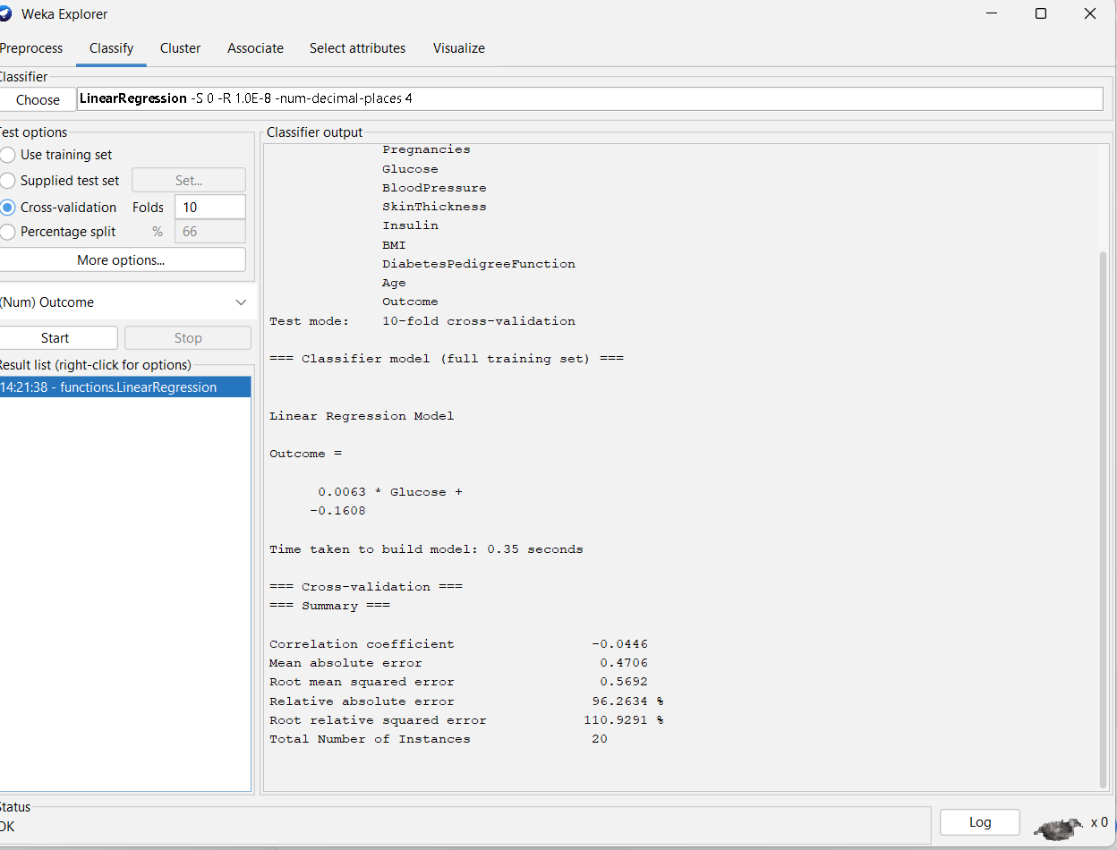

Q5:program
@relation transactions
@attribute M {yes,no}
@attribute O {yes,no}
@attribute N {yes,no}
@attribute K {yes,no}
@attribute E {yes,no}
@attribute Y {yes,no}
@attribute D {yes,no}
@attribute A {yes,no}
@attribute U {yes,no}
@attribute C {yes,no}
@attribute I {yes,no}

@data
yes,yes,yes,yes,yes,yes,no,no,no,no,no
no,yes,yes,yes,yes,yes,yes,no,no,no,no
yes,no,no,yes,yes,no,no,yes,no,no,no
yes,no,no,yes,no,yes,no,no,yes,yes,no
no,yes,no,yes,yes,no,no,no,no,yes,yes
Output:

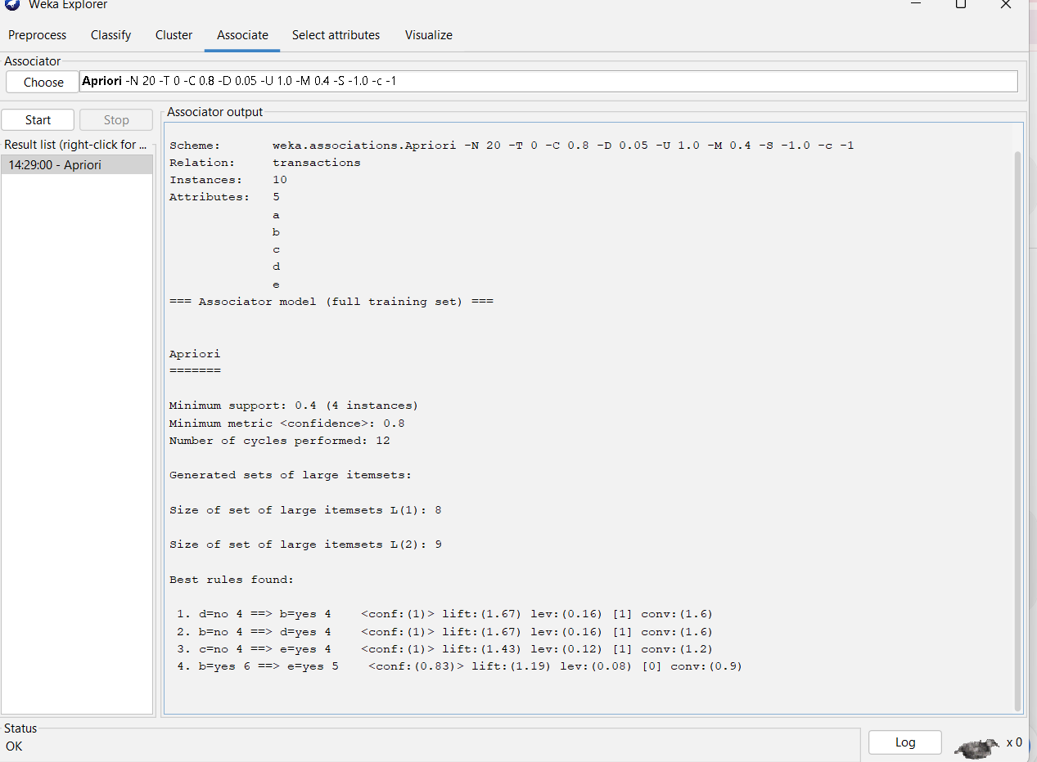

Q6:program
@relation playtennis

@attribute Outlook {Sunny,Overcast,Rain}
@attribute Temperature {Hot,Mild,Cool}
@attribute Humidity {High,Normal}
@attribute Windy {False,True}
@attribute Play_Tennis {Yes,No}

@data
Sunny,Hot,High,False,No
Sunny,Hot,High,True,No
Overcast,Hot,High,False,Yes
Rain,Mild,High,False,Yes
Rain,Cool,Normal,False,Yes
Rain,Cool,Normal,True,No
Overcast,Cool,Normal,True,Yes
Sunny,Mild,High,False,No
Sunny,Cool,Normal,False,Yes
Rain,Mild,Normal,False,Yes
Sunny,Mild,Normal,True,Yes
Overcast,Mild,High,True,Yes
Overcast,Hot,Normal,False,Yes
Rain,Mild,High,True,No @relation playtennis

@attribute Outlook {Sunny,Overcast,Rain}
@attribute Temperature {Hot,Mild,Cool}
@attribute Humidity {High,Normal}
@attribute Windy {False,True}
@attribute Play_Tennis {Yes,No}

@data
Sunny,Hot,High,False,No
Sunny,Hot,High,True,No
Overcast,Hot,High,False,Yes
Rain,Mild,High,False,Yes
Rain,Cool,Normal,False,Yes
Rain,Cool,Normal,True,No
Overcast,Cool,Normal,True,Yes
Sunny,Mild,High,False,No
Sunny,Cool,Normal,False,Yes
Rain,Mild,Normal,False,Yes
Sunny,Mild,Normal,True,Yes
Overcast,Mild,High,True,Yes
Overcast,Hot,Normal,False,Yes

Output:
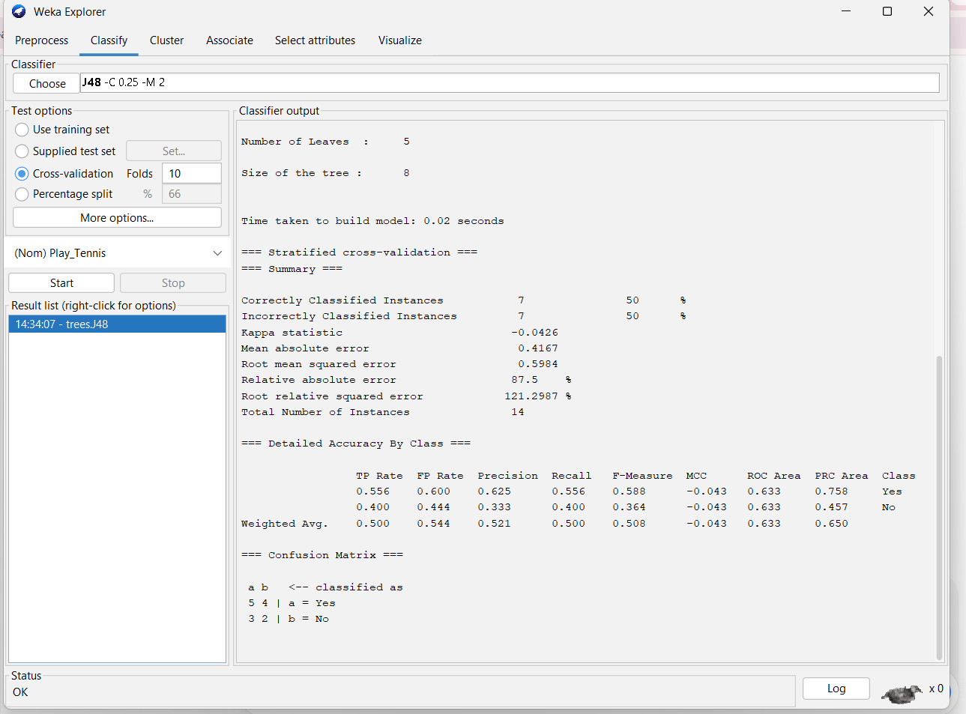
Q7:Program
relation food_transactions
@attribute Hot_Dogs {yes,no}
@attribute Buns {yes,no}
@attribute Ketchup {yes,no}
@attribute Coke {yes,no}
@attribute Chips {yes,no}
@data
yes,yes,yes,no,no
yes,yes,no,no,no
@
yes,no,no,yes,yes
no,no,no,yes,yes
no,no,yes,no,yes
yes,no,no,yes,yes

output:
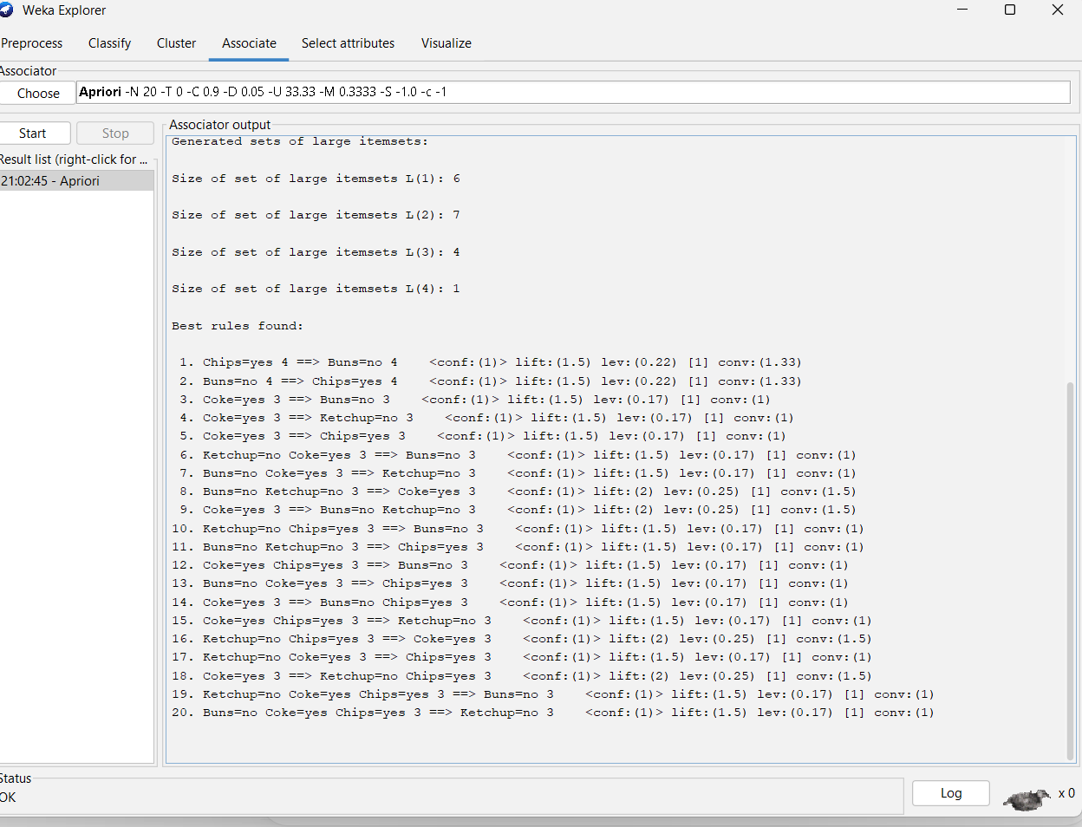
Q8:program
@relation playtennis
@attribute Outlook {Sunny,Overcast,Rain}
@attribute Temperature {Hot,Mild,Cool}
@attribute Humidity {High,Normal}
@attribute Windy {False,True}
@attribute Play_Tennis {Yes,No}
@data
Sunny,Hot,High,False,No
Sunny,Hot,High,True,No
Overcast,Hot,High,False,Yes
Rain,Mild,High,False,Yes
Rain,Cool,Normal,False,Yes
Rain,Cool,Normal,True,No
Overcast,Cool,Normal,True,Yes
Sunny,Mild,High,False,No
Sunny,Cool,Normal,False,Yes
Rain,Mild,Normal,False,Yes
Sunny,Mild,Normal,True,Yes
Overcast,Mild,High,True,Yes
Overcast,Hot,Normal,False,Yes
Rain,Mild,High,True,No
Output:
